**Activity 1** -

Web Servers purpose :

1. Web servers are programs that help us interact with web pages using HTTP (HyperText Transfer Protocol).
2. Web servers store files and data & serves them upon request by any client on the internet. Typically, web servers are powerful computers that are able to handle multiple client requests parallely.

Web servers :

Apache, nginx, Microsoft IIS(Internet Information Server), lighttpd, Tomcat

**Activity 2** -

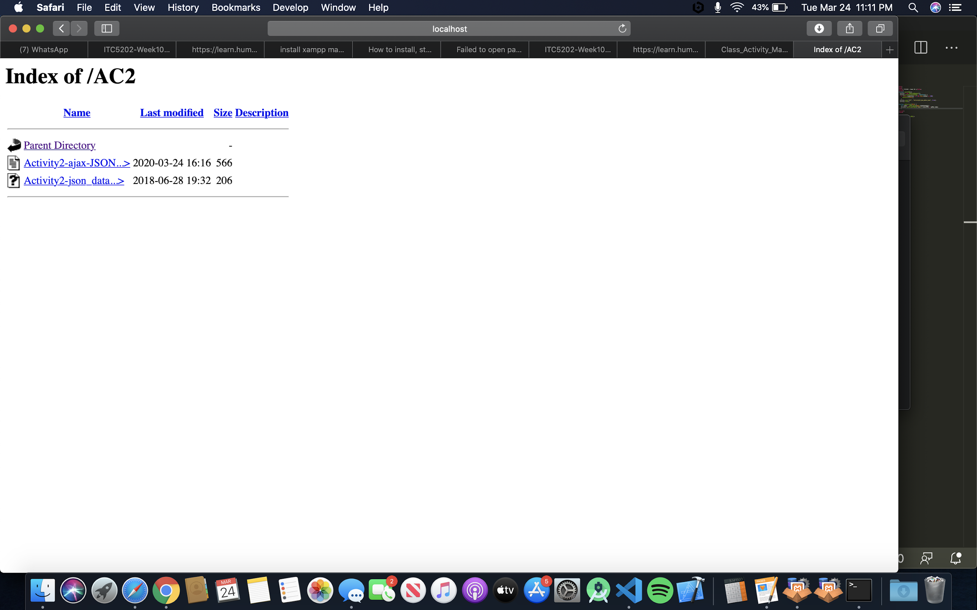

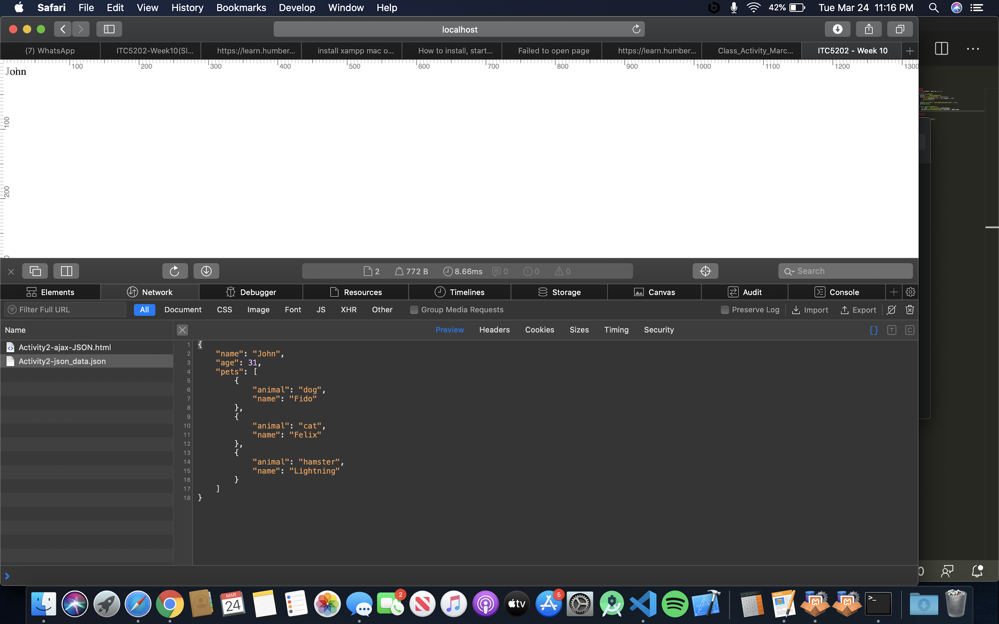

This works similarly to how we have rendered json files using html and JS before. Instead of having a local resource, this is being served from the apache server on the configured port of 8080. Previously, we have run this, but using Visual studio code live server but that did similar things internally.

When the client requests resources from a server, it keeps checking readyState. OnReadyStateChange, from the state of ready state, it knows weather

0: request not initialized 1: server connection established 2: request received 3: processing request 4: request finished and response is ready. If the status is 4, it can process the response from the callback object. After processing the response, it renders the data dynamically on the html. It also checks the http OK status of 200.

Activity 3

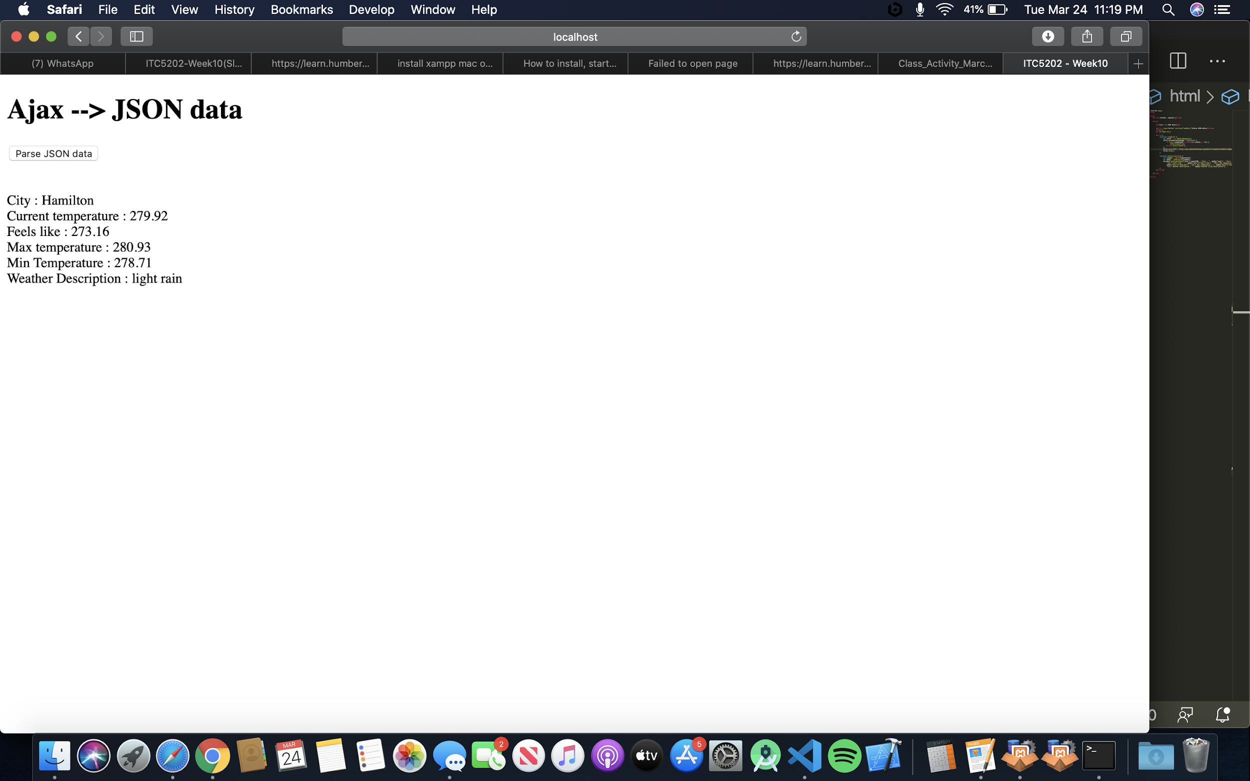

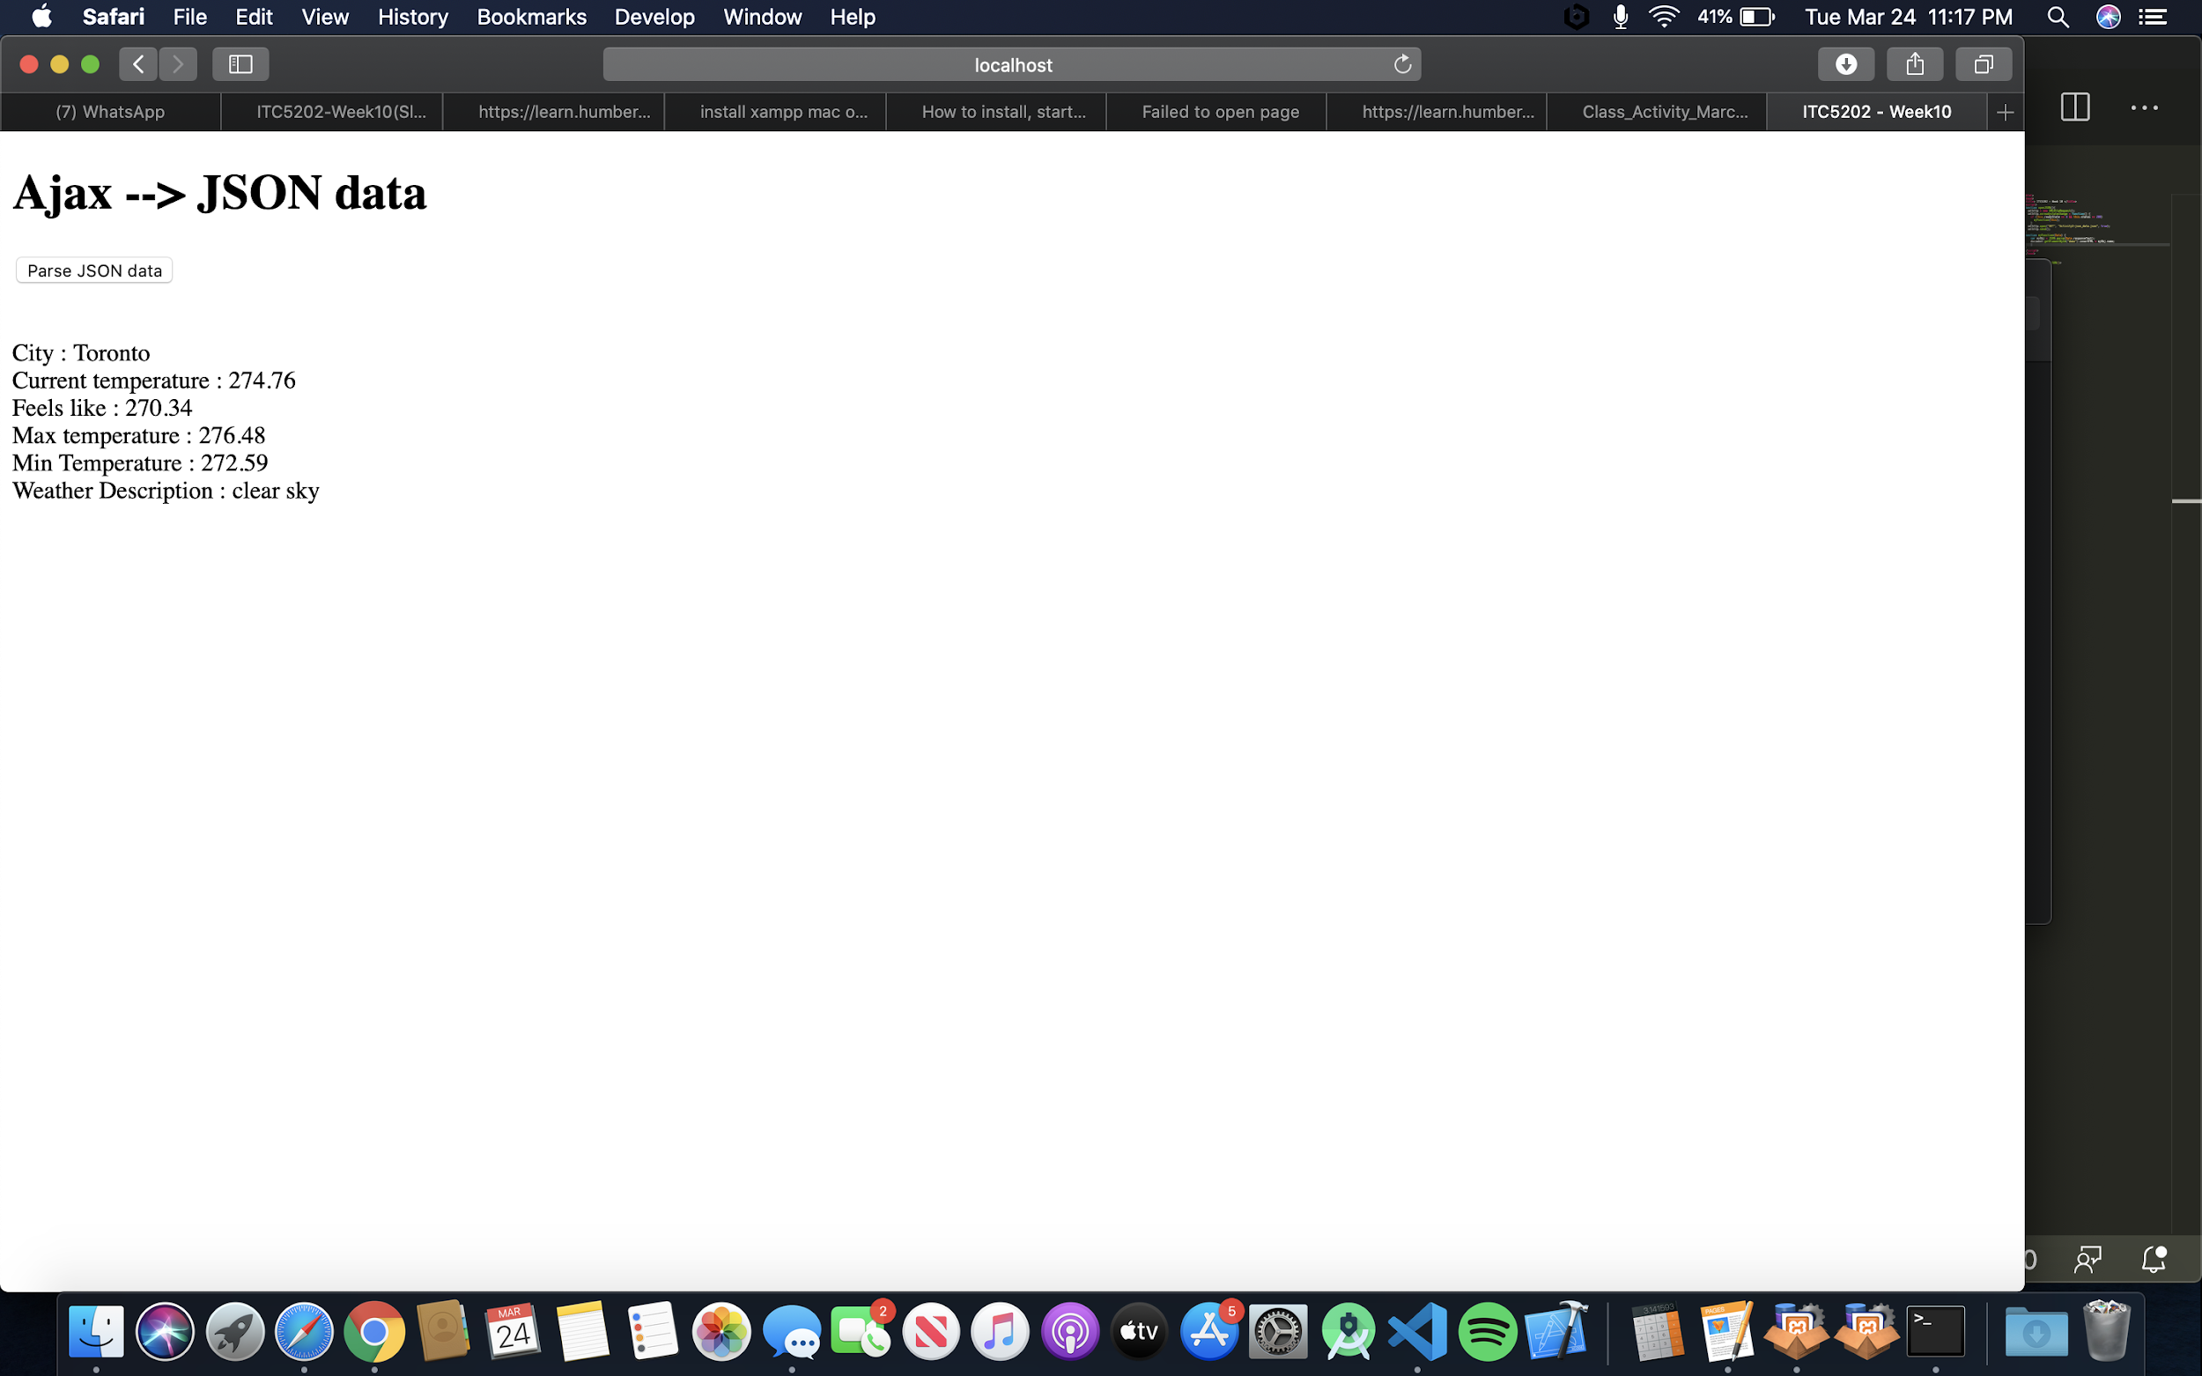

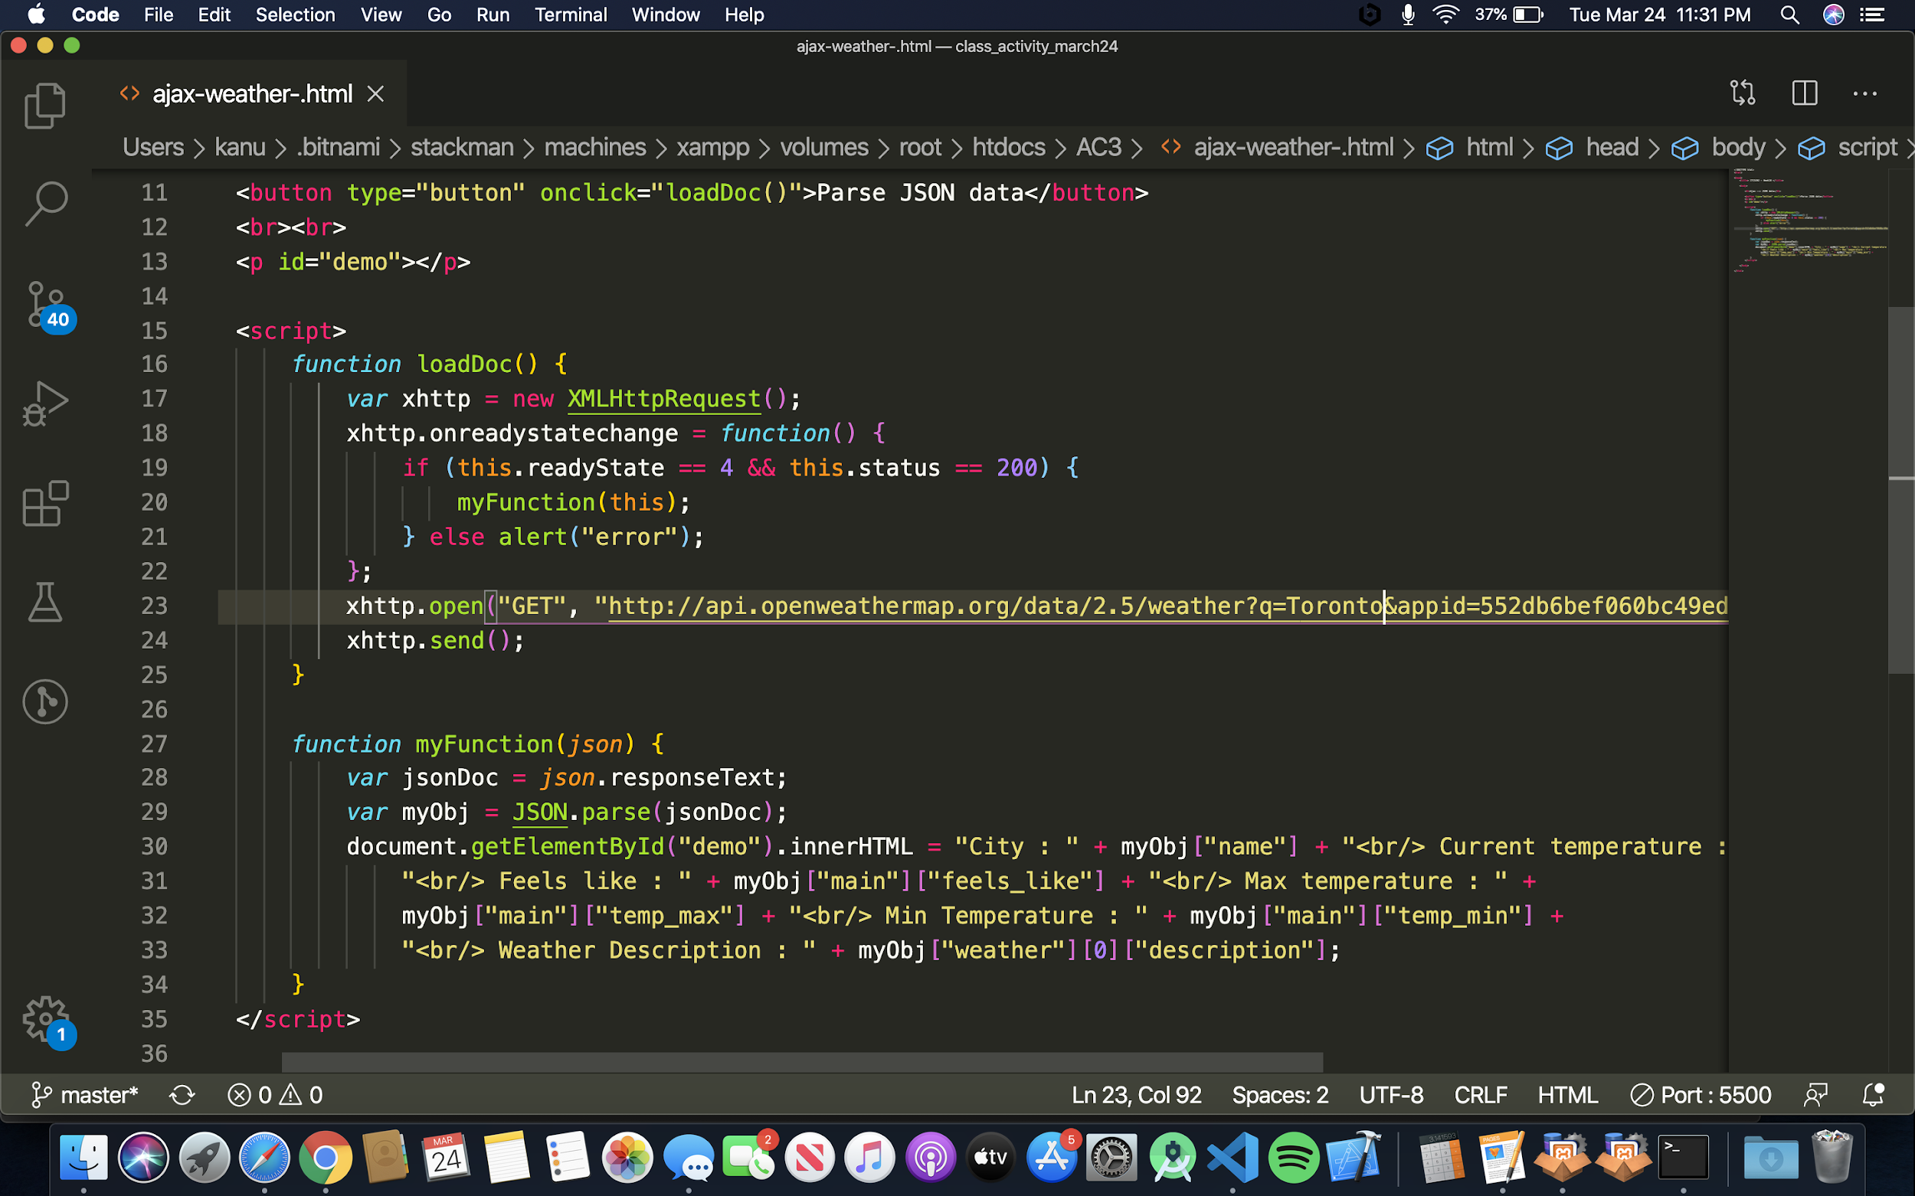

My api key :

